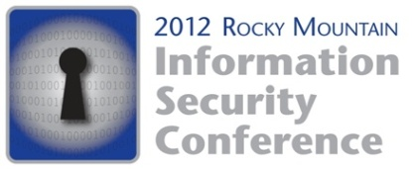
May 17-18, 2012
Sheraton Downtown Denver

DEMOGRAPHIC INFORMATION

RMISC 2011 Conference Demographics*
449 Registrants
Industry | Percentage |  | Position | Percentage
Business Services | 10.56 |  | Academic | 2.61
Computer Security | 12.84 |  | Administrative | 1.12
Education | 5.96 |  | Consultant | 6.72
Entertainment | 4.59 |  | Director | 10.82
Financial Services | 16.97 |  | Manager | 20.15
Government | 16.06 |  | Professional | 48.13
Healthcare | 3.21 |  | Top Level Executive | 3.36
Hospitality | .92 |  | Other | 7.09
Manufacturing | 5.05
Retail | 0
Telecommunications | 10.09
Other | 13.76

RMISC 2010 Conference Demographics*
305 Registrants
Industry | Percentage |  | Position | Percentage
Business Services | 4.26 |  | Academic | .98
Computer Security | 26.6 |  | Administrative | .98
Education | 4.59 |  | Consultant | 11.5
Entertainment | .66 |  | Director | 15.4
Financial Services | 20 |  | Manager | 24.3
Government | 9.51 |  | Professional | 34.8
Healthcare | 3.28 |  | Top Level Executive | 5.25
Hospitality | .66 |  | Other | 21
Manufacturing | 4.26
Retail | .33
Telecommunications | 8.2
Other | 17.7

*numbers based on those who responded to demographic questions during registration process

