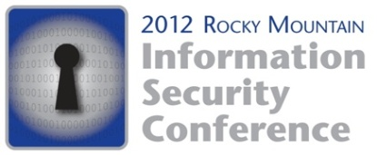

May 17-18, 2012

Sheraton Downtown Denver

Sponsorship Packages

The Denver chapters of ISACA and ISSA invite you to reach technical security engineers, audit and compliance personnel, executive management (CEO, CIO, CFO, CISO, CSO, CTO), as well as many members of their support team. Where else can you find 500+ professionals eager to learn about YOUR new products and services?
Platinum Sponsor $8,000
All Gold Level Sponsor benefits, PLUS …
- Two additional complimentary representative registrations for a total of 8
- Logo on conference Registration site welcome page
- Logo on conference Tote Bag
- Logo on all conference signage (excluding sponsored events)
- Color ad receives premium location in conference program
- Expanded company description in conference program of up to 150 words
- Guaranteed Workshop speaking slot on Friday May 18, 2012
(commitment required by 2/15/12)
- Introduction of opening or closing keynote speaker (limited to first 2 companies)
Gold Sponsor $6,000
All Silver Sponsor benefits, PLUS …
- Booth Space upgraded to 20 x 20
- Priority booth location for maximum visibility
- Two additional complimentary representative registrations for a total of 6
- Logo Recognition on Conference program cover
- Color ad upgraded to Full Page
- Company literature (brochure/flyer) permitted in conference tote bag
- Logo Recognition on Conference slide for General Sessions
- Preferential consideration for a workshop speaking slot on Friday May 18, 2012
(commitment required by 2/15/12)
- Introduction of a Workshop Session
- Access to attendee opt-in list pre-conference in addition to post conference
Silver Sponsor $4,000
All Bronze Sponsor benefits, PLUS …
- Two additional complimentary representative registrations for a total of 4
- Use of RMISC 2012 logo on your company social marketing network pages
- Half (1/2) page color ad in the conference program
- Company description in conference program up to 75 words
Bronze Sponsor $2,600
- Includes 10 x 10 booth and 2 complimentary representative registrations
- Logo Recognition and placement on 1-meter Sponsorship Sign
- Logo Recognition on Conference Website with hyperlink to company website
- Ability to place promotional item (non-brochure) in conference tote bag
- Sponsorship level recognition on name badge
- Access to Opt In attendee list, post-conference
Exhibit Booth Only $2,200
Includes 10 x 10 booth and 2 complimentary representative registrations

